COMET H422 MOD for 50 Mhz

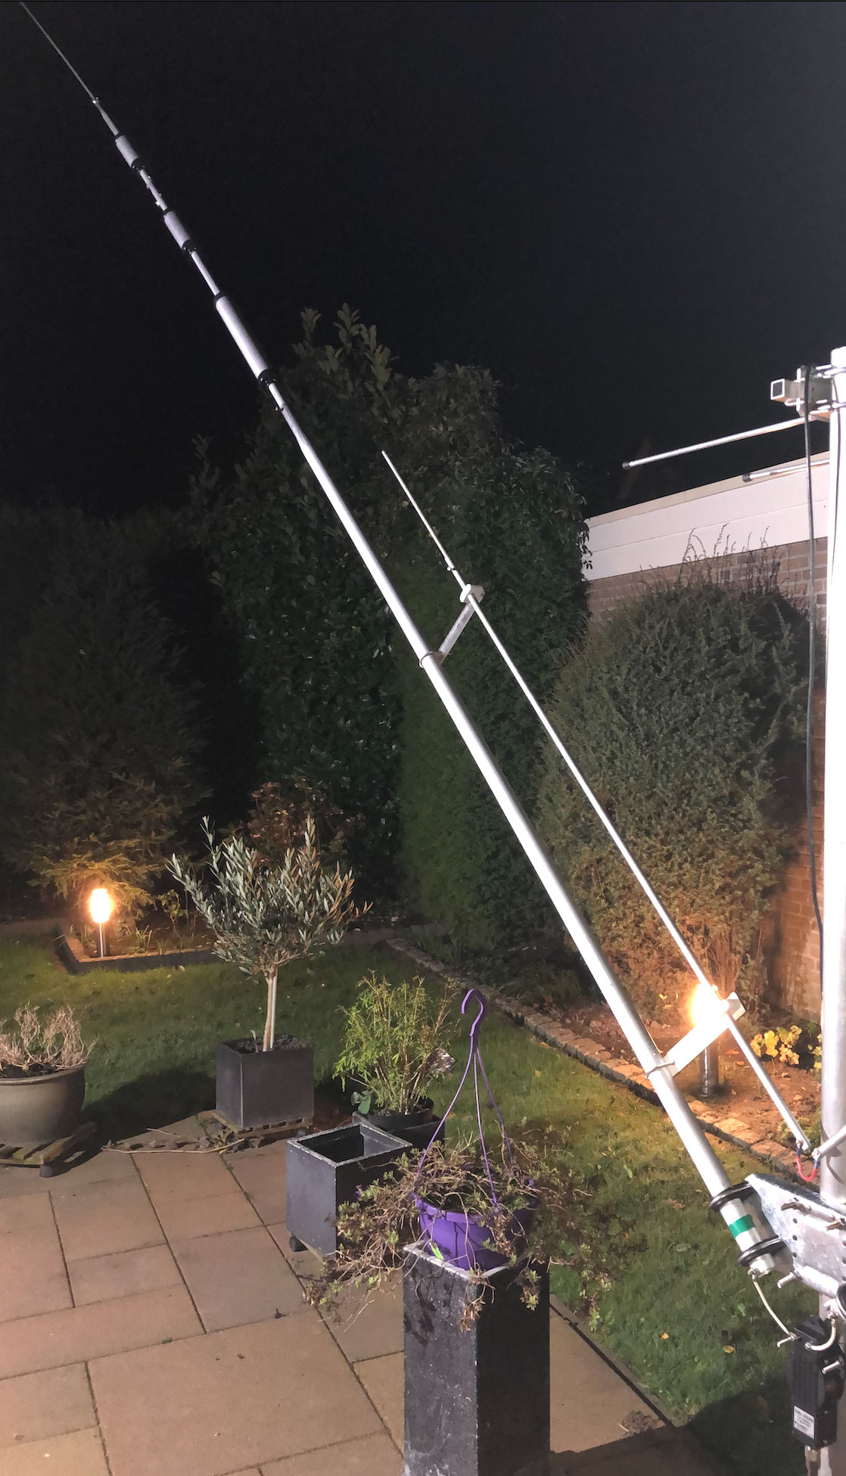
This is a short description of my mod to make my Comet H422 usable on the 50Mhz band.
The idea I got when I saw a multiband dipole from ProSisTel, which is quite similar to the Comet, having this add-on for 50Mhz.

I had the opportunity to measure the Italian antenna and decided to see if it worked by building this mod myself with material available.
And it worked. See the diagram on the next page.
I used a Nano VNA for this measurement, which had proven to be ok when compared with a more professional AntennaRIG

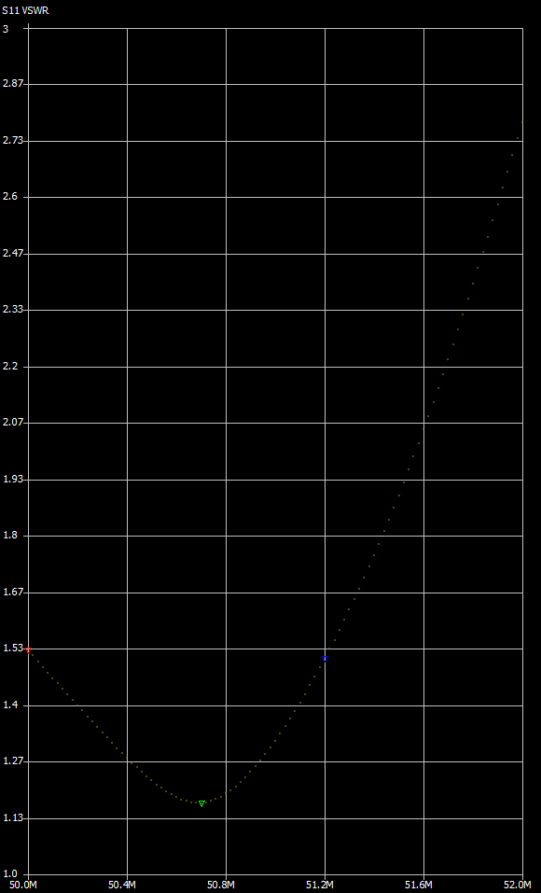
SWR in my case at 50.5 Mhz was 1.15.

So what do you need:

- 4 strips of Trespa or plexiglass 20x2 cm at least 5mm thick
- One aluminum tube with an outer diameter of 12mm and a length of 1m20.
- One aluminum tube that fits in the tube above (for me it was an outer diameter of 9mm) with a length of about 80cm.
- Four (4) pieces of M4 threaded rod to bend into a U profile, or fitting auto muffler clamps.
- Some bolts and nuts M3 and/or M4 and
- 4 saddle clamps for electricity tube.

Cut both tubes in half, so you have two tubes of 60cm with an outer diameter of 12 mm and two tubes which fit into these tubes of each 40cm

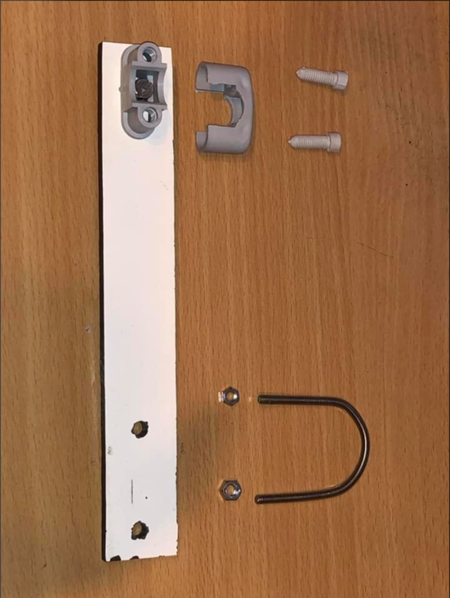
Create 4 distance holders as per picture on the left. The Trespa / Plexiglas strips are 20x2 cm each and are 5mm thick.
The distance between the middle of the saddle clamp and the middles of the two holes for the U-bent thread-rod is 15cm.
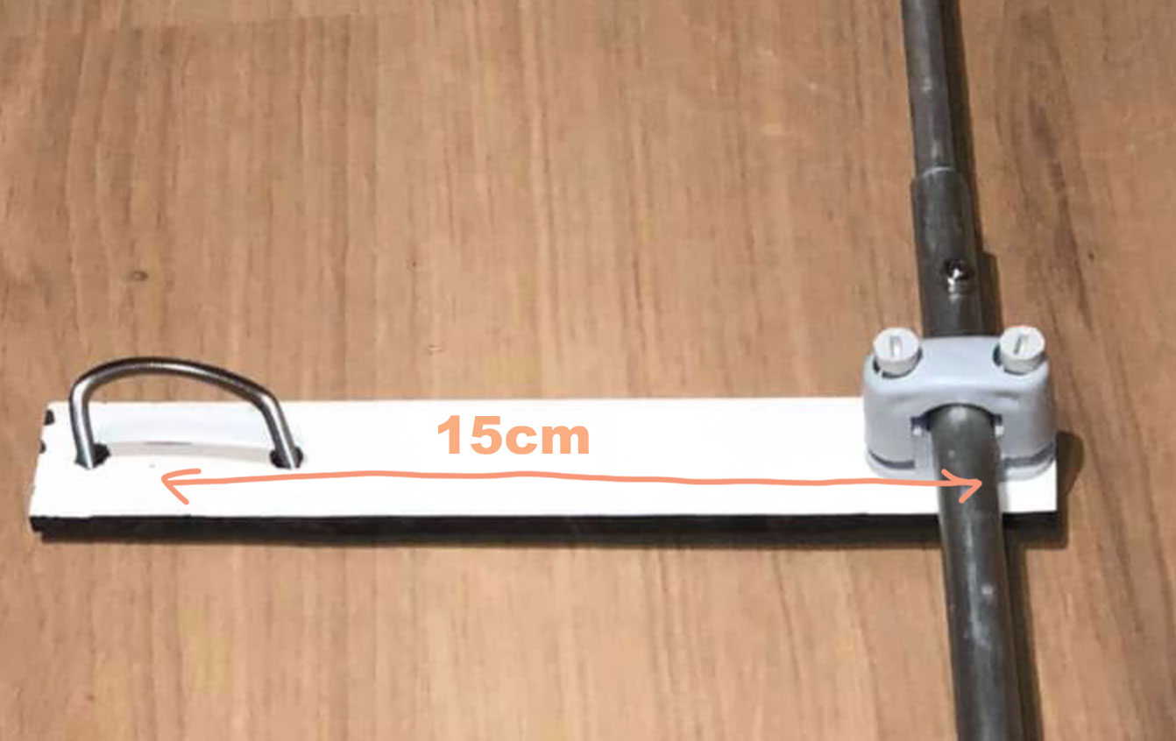
If you can get hold of small auto muffler clamps, it’s even better. Just make sure they will go around the first element on the left and right of the dipole, so measure
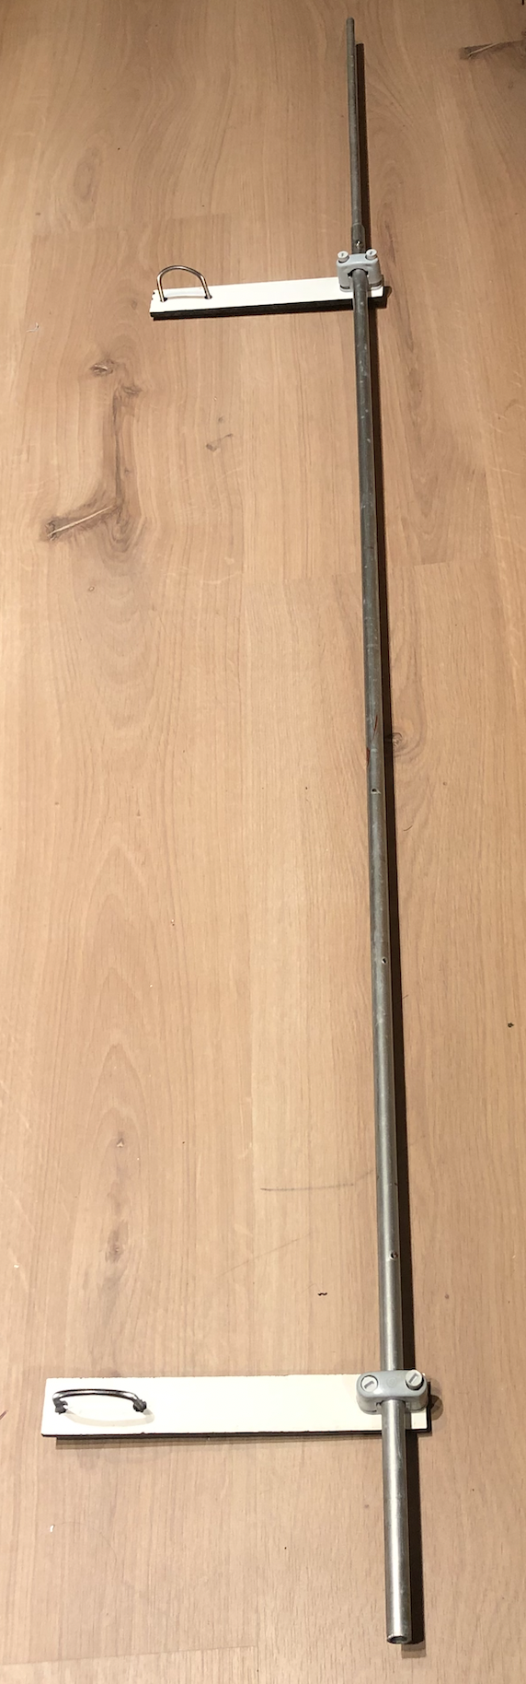
the diameter of that tube first before bending. I used the good old wooden broomstick here to bend it around.

In order to tune this antenna, I stuck the smaller tube in the bigger one until in total the length of one element was 146cm.
Then I drilled a hole of 3mm through both tubes, to fix the smaller tube with the bigger one.

For adjustment purposes I made a couple of holes more left and right of this one, each spaced one cm. This will give me opportunity to tune the antenna to the desired frequency.
How many holes is up to you!
I drilled 5 more holes towards the center and two more toward the end. So, all in all there are 8 holes.

Note: I suggest you grease all electrical connections with copper grease. You can get it in the automotive shops, where they use it for battery connections.

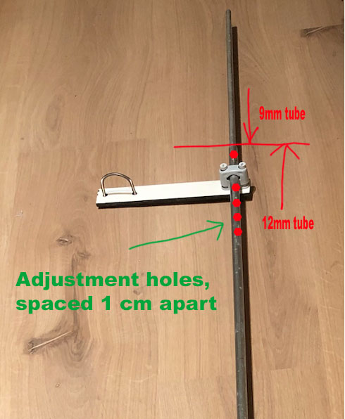

Now mount both elements to the Comet as per picture below.
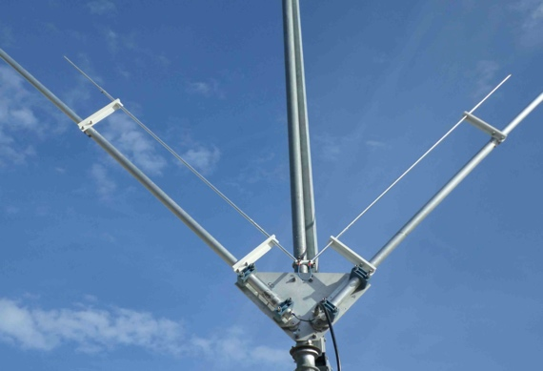
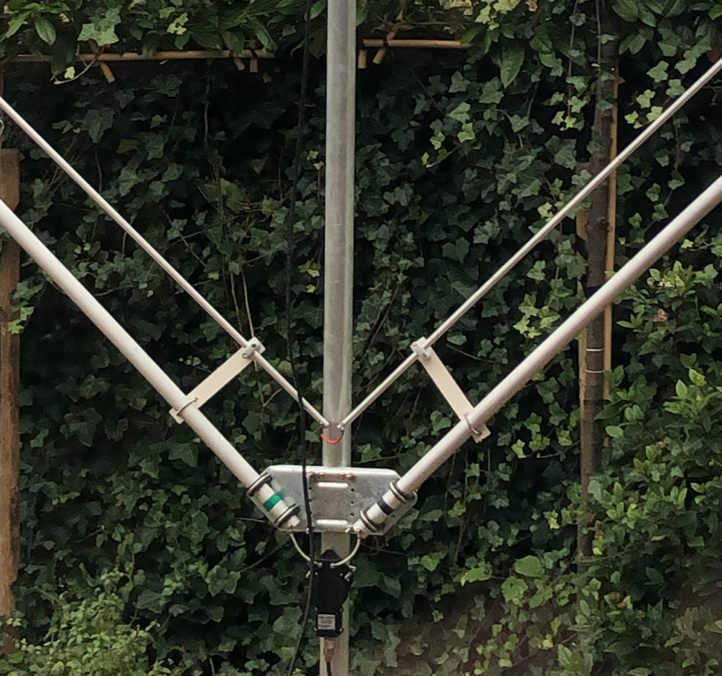

Above is a picture of the original prosistel…. Left is my mod.

Connect the centers together with a piece of 1.5 or thicker alu / copper wire, or a strip of copper.
There is no connection to the coaxial cable or so. That’s it. You’r done, so put the antenna back on the mast. Or maybe tune it first when still at the ground

Tuning the antenna
Start tuning at 50Mhz with a length of 146 cm for both radiators so 120cm from the 12mm tube and the rest with the 9mm tube. I drilled holes through the small tube every 10 mm so that I can fasten them with M3.
Tuning can be done with an VNA or other type of antenna analyzer, or simply by measuring the VSWR.

SWR in my case at 50.4 was approx. 1.2.
If you want to go up, shorten the antenna, and make it longer for going lower in frequency.

Have fun and good luck with this mod. It’ll most likely also work on FB13 and other similar multiband dipoles.

Erik, PA0ESH

